**The following questions are from Lecture 49**

Question: 1

1.   
   Sir, please I need to know “why”. “Why” is very important to satisfy curiosity.

Question: 2

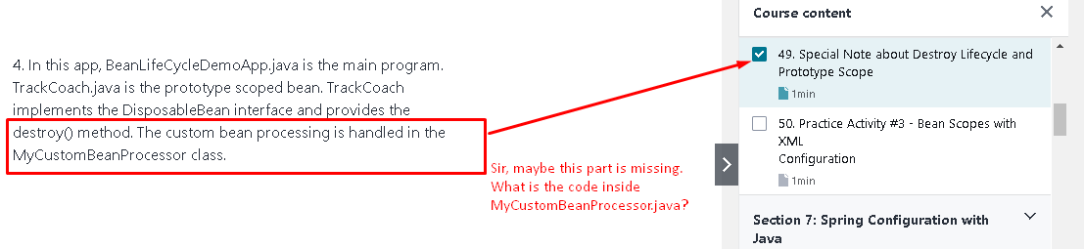

Question: 3

